Họ tên: Lê Thị Anh Thư
Lớp: 11_TMĐT
MSSV: 1150070042
BÀI TẬP LÝ THUYẾT 7

Bước 1: Thiết lập Project và Permissions
Tạo một project mới với "Empty Activity" trong Android Studio.

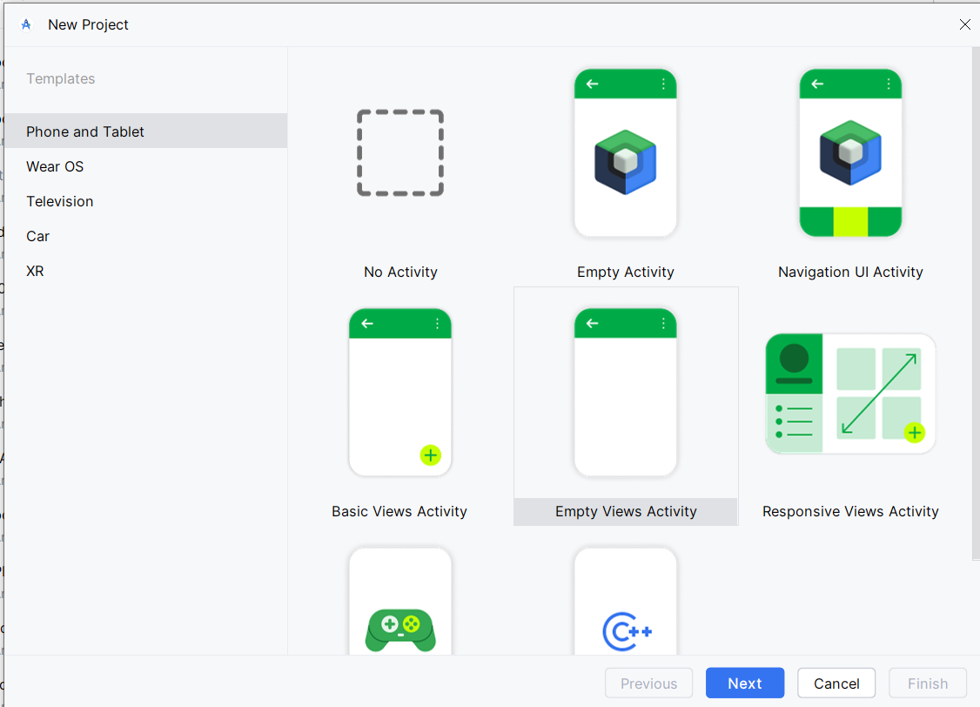
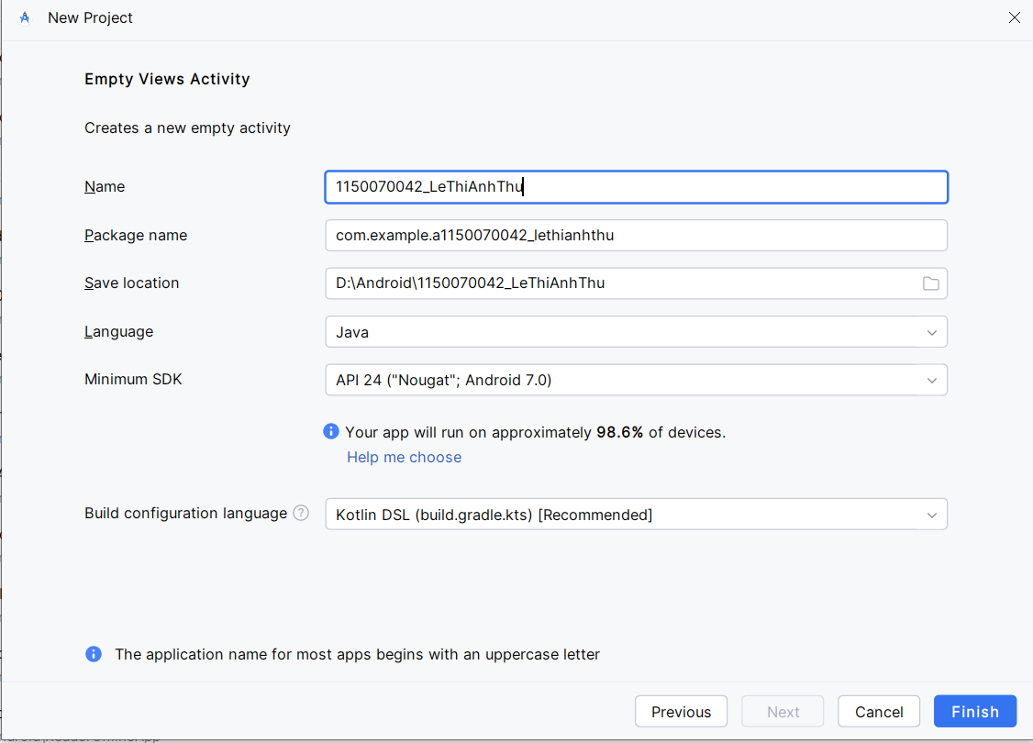

Bước 2: Thiết kế Giao diện (Layout)
Giao diện chính (res/layout/activity_main.xml): Tạo một EditText để nhập URL và một Button để bắt đầu download.
package com.example.a1150070042_lethianhthu;
import android.app.Notification;
import android.app.NotificationChannel;
import android.app.NotificationManager;
import android.app.PendingIntent;
import android.app.Service;
import android.content.Intent;
import android.os.Build;
import android.os.IBinder;
import android.util.Log;
import android.widget.RemoteViews;
import android.widget.Toast;
import androidx.annotation.Nullable;
import androidx.core.app.NotificationCompat;
import java.io.File;
import java.io.FileOutputStream;
import java.io.InputStream;
import java.net.HttpURLConnection;
import java.net.URL;
public class DownloadService extends Service {
private static final int NOTIFICATION_ID = 1;
private static final String CHANNEL_ID = "DownloadChannel";
private static final String TAG = "DownloadService"; // Thêm TAG để lọc log
public static final String ACTION_START = "com.example.ACTION_START";
public static final String ACTION_PAUSE = "com.example.ACTION_PAUSE";
public static final String ACTION_RESUME = "com.example.ACTION_RESUME";
public static final String ACTION_CANCEL = "com.example.ACTION_CANCEL";
private NotificationManager notificationManager;
private NotificationCompat.Builder notificationBuilder;
private RemoteViews remoteViews;
private Thread downloadThread;
private volatile boolean isPaused = false;
private volatile boolean isCancelled = false;
@Override
public void onCreate() {
super.onCreate();
notificationManager = (NotificationManager) getSystemService(NOTIFICATION_SERVICE);
createNotificationChannel();
}
@Override
public int onStartCommand(Intent intent, int flags, int startId) {
if (intent != null && intent.getAction() != null) {
String action = intent.getAction();
switch (action) {
case ACTION_START:
// Ngăn việc bắt đầu download mới nếu đã có một tiến trình đang chạy
if (downloadThread != null && downloadThread.isAlive()) {
Toast.makeText(this, "A download is already in progress.", Toast.LENGTH_SHORT).show();
return START_NOT_STICKY;
}
String url = intent.getStringExtra("url");
startDownload(url);
break;
case ACTION_PAUSE:
pauseDownload();
break;
case ACTION_RESUME:
resumeDownload();
break;
case ACTION_CANCEL:
cancelDownload();
break;
}
}
return START_NOT_STICKY;
}
private void startDownload(String urlString) {
isCancelled = false;
isPaused = false;
startForeground(NOTIFICATION_ID, createNotification());
downloadThread = new Thread(() -> {
HttpURLConnection connection = null;
InputStream input = null;
FileOutputStream output = null;
try {
URL url = new URL(urlString);
connection = (HttpURLConnection) url.openConnection();
connection.connect();
int responseCode = connection.getResponseCode();
Log.d(TAG, "Server Response Code: " + responseCode); // In log response code
if (responseCode != HttpURLConnection.HTTP_OK) {
throw new Exception("Server returned HTTP " + responseCode
+ " " + connection.getResponseMessage());
}
int fileLength = connection.getContentLength();
input = connection.getInputStream();
File file = new File(getFilesDir(), "downloaded_file.dat");
output = new FileOutputStream(file);
byte[] data = new byte[4096];
long total = 0;
int count;
while ((count = input.read(data)) != -1) {
if (isCancelled) {
break;
}
while (isPaused) {
Thread.sleep(100);
}
total += count;
output.write(data, 0, count);
if (fileLength > 0) {
int progress = (int) (total * 100 / fileLength);
updateNotificationProgress(progress);
}
}
// **SỬA LỖI 1: Xử lý trạng thái cuối cùng**
if (isCancelled) {
file.delete();
Log.d(TAG, "Download cancelled, file deleted.");
} else {
Log.d(TAG, "Download completed successfully.");
updateNotificationCompleted();
}
} catch (Exception e) {
Log.e(TAG, "Download failed", e); // In chi tiết lỗi ra Logcat
updateNotificationFailed();
} finally {
try {
if (output != null) output.close();
if (input != null) input.close();
} catch (Exception e) {
e.printStackTrace();
}
if (connection != null) connection.disconnect();
// **SỬA LỖI 2: Dừng service sau khi tác vụ hoàn thành**
stopForeground(false); // Giữ lại notification sau khi xong
stopSelf(); // Tự hủy service
}
});
downloadThread.start();
}
private void pauseDownload() {
if (remoteViews == null || notificationBuilder == null) return;
isPaused = true;
remoteViews.setImageViewResource(R.id.btn_pause_resume, android.R.drawable.ic_media_play);
remoteViews.setOnClickPendingIntent(R.id.btn_pause_resume, createPendingIntent(ACTION_RESUME));
notificationManager.notify(NOTIFICATION_ID, notificationBuilder.build());
Toast.makeText(this, "Download Paused", Toast.LENGTH_SHORT).show();
}
private void resumeDownload() {
if (remoteViews == null || notificationBuilder == null) return;
isPaused = false;
remoteViews.setImageViewResource(R.id.btn_pause_resume, android.R.drawable.ic_media_pause);
remoteViews.setOnClickPendingIntent(R.id.btn_pause_resume, createPendingIntent(ACTION_PAUSE));
notificationManager.notify(NOTIFICATION_ID, notificationBuilder.build());
Toast.makeText(this, "Download Resumed", Toast.LENGTH_SHORT).show();
}
private void cancelDownload() {
isCancelled = true;
if (downloadThread != null) {
downloadThread.interrupt();
}
stopForeground(true); // Dừng foreground và xóa notification ngay lập tức
stopSelf();
Toast.makeText(this, "Download Canceled", Toast.LENGTH_SHORT).show();
}
private void createNotificationChannel() {
if (Build.VERSION.SDK_INT >= Build.VERSION_CODES.O) {
NotificationChannel serviceChannel = new NotificationChannel(
CHANNEL_ID, "Download Service Channel", NotificationManager.IMPORTANCE_LOW
);
notificationManager.createNotificationChannel(serviceChannel);
}
}
private Notification createNotification() {
remoteViews = new RemoteViews(getPackageName(), R.layout.notification_layout);
remoteViews.setProgressBar(R.id.notification_progress, 100, 0, false);
remoteViews.setTextViewText(R.id.notification_title, "Downloading file...");
remoteViews.setOnClickPendingIntent(R.id.btn_pause_resume, createPendingIntent(ACTION_PAUSE));
remoteViews.setOnClickPendingIntent(R.id.btn_cancel, createPendingIntent(ACTION_CANCEL));
notificationBuilder = new NotificationCompat.Builder(this, CHANNEL_ID)
// **SỬA LỖI 3: Dùng icon chuẩn cho download**
.setSmallIcon(android.R.drawable.stat_sys_download)
.setCustomContentView(remoteViews)
.setOnlyAlertOnce(true)
.setOngoing(true);
return notificationBuilder.build();
}
private PendingIntent createPendingIntent(String action) {
Intent intent = new Intent(this, NotificationBroadcastReceiver.class);
intent.setAction(action);
return PendingIntent.getBroadcast(this, 0, intent, PendingIntent.FLAG_UPDATE_CURRENT | PendingIntent.FLAG_IMMUTABLE);
}
private void updateNotificationProgress(int progress) {
if (remoteViews == null || notificationBuilder == null) return;
remoteViews.setProgressBar(R.id.notification_progress, 100, progress, false);
notificationManager.notify(NOTIFICATION_ID, notificationBuilder.build());
}
private void updateNotificationCompleted() {
if (remoteViews == null || notificationBuilder == null) return;
remoteViews.setTextViewText(R.id.notification_title, "Download Completed");
remoteViews.setProgressBar(R.id.notification_progress, 100, 100, false); // Hiện 100%
notificationBuilder.setOngoing(false);
notificationManager.notify(NOTIFICATION_ID, notificationBuilder.build());
}
private void updateNotificationFailed() {
if (remoteViews == null || notificationBuilder == null) return;
remoteViews.setTextViewText(R.id.notification_title, "Download Failed");
remoteViews.setProgressBar(R.id.notification_progress, 0, 0, false);
notificationBuilder.setOngoing(false);
notificationManager.notify(NOTIFICATION_ID, notificationBuilder.build());
}
@Override
public void onDestroy() {
super.onDestroy();
Log.d(TAG, "Service destroyed.");
if (downloadThread != null) {
downloadThread.interrupt();
}
notificationManager.cancel(NOTIFICATION_ID);
}
@Nullable
@Override
public IBinder onBind(Intent intent) {
return null;
}
}

Giao diện Notification tùy chỉnh (res/layout/notification_layout.xml): Đây là layout sẽ hiển thị trên thanh thông báo.
package com.example.a1150070042_lethianhthu;
import android.app.Notification;
import android.app.NotificationChannel;
import android.app.NotificationManager;
import android.app.PendingIntent;
import android.app.Service;
import android.content.Intent;
import android.os.Build;
import android.os.IBinder;
import android.util.Log;
import android.widget.RemoteViews;
import android.widget.Toast;
import androidx.annotation.Nullable;
import androidx.core.app.NotificationCompat;
import java.io.File;
import java.io.FileOutputStream;
import java.io.InputStream;
import java.net.HttpURLConnection;
import java.net.URL;
public class DownloadService extends Service {
private static final int NOTIFICATION_ID = 1;
private static final String CHANNEL_ID = "DownloadChannel";
private static final String TAG = "DownloadService"; // Thêm TAG để lọc log
public static final String ACTION_START = "com.example.ACTION_START";
public static final String ACTION_PAUSE = "com.example.ACTION_PAUSE";
public static final String ACTION_RESUME = "com.example.ACTION_RESUME";
public static final String ACTION_CANCEL = "com.example.ACTION_CANCEL";
private NotificationManager notificationManager;
private NotificationCompat.Builder notificationBuilder;
private RemoteViews remoteViews;
private Thread downloadThread;
private volatile boolean isPaused = false;
private volatile boolean isCancelled = false;
@Override
public void onCreate() {
super.onCreate();
notificationManager = (NotificationManager) getSystemService(NOTIFICATION_SERVICE);
createNotificationChannel();
}
@Override
public int onStartCommand(Intent intent, int flags, int startId) {
if (intent != null && intent.getAction() != null) {
String action = intent.getAction();
switch (action) {
case ACTION_START:
// Ngăn việc bắt đầu download mới nếu đã có một tiến trình đang chạy
if (downloadThread != null && downloadThread.isAlive()) {
Toast.makeText(this, "A download is already in progress.", Toast.LENGTH_SHORT).show();
return START_NOT_STICKY;
}
String url = intent.getStringExtra("url");
startDownload(url);
break;
case ACTION_PAUSE:
pauseDownload();
break;
case ACTION_RESUME:
resumeDownload();
break;
case ACTION_CANCEL:
cancelDownload();
break;
}
}
return START_NOT_STICKY;
}
private void startDownload(String urlString) {
isCancelled = false;
isPaused = false;
startForeground(NOTIFICATION_ID, createNotification());
downloadThread = new Thread(() -> {
HttpURLConnection connection = null;
InputStream input = null;
FileOutputStream output = null;
try {
URL url = new URL(urlString);
connection = (HttpURLConnection) url.openConnection();
connection.connect();
int responseCode = connection.getResponseCode();
Log.d(TAG, "Server Response Code: " + responseCode); // In log response code
if (responseCode != HttpURLConnection.HTTP_OK) {
throw new Exception("Server returned HTTP " + responseCode
+ " " + connection.getResponseMessage());
}
int fileLength = connection.getContentLength();
input = connection.getInputStream();
File file = new File(getFilesDir(), "downloaded_file.dat");
output = new FileOutputStream(file);
byte[] data = new byte[4096];
long total = 0;
int count;
while ((count = input.read(data)) != -1) {
if (isCancelled) {
break;
}
while (isPaused) {
Thread.sleep(100);
}
total += count;
output.write(data, 0, count);
if (fileLength > 0) {
int progress = (int) (total * 100 / fileLength);
updateNotificationProgress(progress);
}
}
// **SỬA LỖI 1: Xử lý trạng thái cuối cùng**
if (isCancelled) {
file.delete();
Log.d(TAG, "Download cancelled, file deleted.");
} else {
Log.d(TAG, "Download completed successfully.");
updateNotificationCompleted();
}
} catch (Exception e) {
Log.e(TAG, "Download failed", e); // In chi tiết lỗi ra Logcat
updateNotificationFailed();
} finally {
try {
if (output != null) output.close();
if (input != null) input.close();
} catch (Exception e) {
e.printStackTrace();
}
if (connection != null) connection.disconnect();
// **SỬA LỖI 2: Dừng service sau khi tác vụ hoàn thành**
stopForeground(false); // Giữ lại notification sau khi xong
stopSelf(); // Tự hủy service
}
});
downloadThread.start();
}
private void pauseDownload() {
if (remoteViews == null || notificationBuilder == null) return;
isPaused = true;
remoteViews.setImageViewResource(R.id.btn_pause_resume, android.R.drawable.ic_media_play);
remoteViews.setOnClickPendingIntent(R.id.btn_pause_resume, createPendingIntent(ACTION_RESUME));
notificationManager.notify(NOTIFICATION_ID, notificationBuilder.build());
Toast.makeText(this, "Download Paused", Toast.LENGTH_SHORT).show();
}
private void resumeDownload() {
if (remoteViews == null || notificationBuilder == null) return;
isPaused = false;
remoteViews.setImageViewResource(R.id.btn_pause_resume, android.R.drawable.ic_media_pause);
remoteViews.setOnClickPendingIntent(R.id.btn_pause_resume, createPendingIntent(ACTION_PAUSE));
notificationManager.notify(NOTIFICATION_ID, notificationBuilder.build());
Toast.makeText(this, "Download Resumed", Toast.LENGTH_SHORT).show();
}
private void cancelDownload() {
isCancelled = true;
if (downloadThread != null) {
downloadThread.interrupt();
}
stopForeground(true); // Dừng foreground và xóa notification ngay lập tức
stopSelf();
Toast.makeText(this, "Download Canceled", Toast.LENGTH_SHORT).show();
}
private void createNotificationChannel() {
if (Build.VERSION.SDK_INT >= Build.VERSION_CODES.O) {
NotificationChannel serviceChannel = new NotificationChannel(
CHANNEL_ID, "Download Service Channel", NotificationManager.IMPORTANCE_LOW
);
notificationManager.createNotificationChannel(serviceChannel);
}
}
private Notification createNotification() {
remoteViews = new RemoteViews(getPackageName(), R.layout.notification_layout);
remoteViews.setProgressBar(R.id.notification_progress, 100, 0, false);
remoteViews.setTextViewText(R.id.notification_title, "Downloading file...");
remoteViews.setOnClickPendingIntent(R.id.btn_pause_resume, createPendingIntent(ACTION_PAUSE));
remoteViews.setOnClickPendingIntent(R.id.btn_cancel, createPendingIntent(ACTION_CANCEL));
notificationBuilder = new NotificationCompat.Builder(this, CHANNEL_ID)
// **SỬA LỖI 3: Dùng icon chuẩn cho download**
.setSmallIcon(android.R.drawable.stat_sys_download)
.setCustomContentView(remoteViews)
.setOnlyAlertOnce(true)
.setOngoing(true);
return notificationBuilder.build();
}
private PendingIntent createPendingIntent(String action) {
Intent intent = new Intent(this, NotificationBroadcastReceiver.class);
intent.setAction(action);
return PendingIntent.getBroadcast(this, 0, intent, PendingIntent.FLAG_UPDATE_CURRENT | PendingIntent.FLAG_IMMUTABLE);
}
private void updateNotificationProgress(int progress) {
if (remoteViews == null || notificationBuilder == null) return;
remoteViews.setProgressBar(R.id.notification_progress, 100, progress, false);
notificationManager.notify(NOTIFICATION_ID, notificationBuilder.build());
}
private void updateNotificationCompleted() {
if (remoteViews == null || notificationBuilder == null) return;
remoteViews.setTextViewText(R.id.notification_title, "Download Completed");
remoteViews.setProgressBar(R.id.notification_progress, 100, 100, false); // Hiện 100%
notificationBuilder.setOngoing(false);
notificationManager.notify(NOTIFICATION_ID, notificationBuilder.build());
}
private void updateNotificationFailed() {
if (remoteViews == null || notificationBuilder == null) return;
remoteViews.setTextViewText(R.id.notification_title, "Download Failed");
remoteViews.setProgressBar(R.id.notification_progress, 0, 0, false);
notificationBuilder.setOngoing(false);
notificationManager.notify(NOTIFICATION_ID, notificationBuilder.build());
}
@Override
public void onDestroy() {
super.onDestroy();
Log.d(TAG, "Service destroyed.");
if (downloadThread != null) {
downloadThread.interrupt();
}
notificationManager.cancel(NOTIFICATION_ID);
}
@Nullable
@Override
public IBinder onBind(Intent intent) {
return null;
}
}

Bước 3: Tạo BroadcastReceiver
Tạo một class mới tên là NotificationBroadcastReceiver.java. Class này sẽ nhận các sự kiện click từ nút trên Notification và gửi lệnh tương ứng đến DownloadService.
package com.example.a1150070042_lethianhthu;
import android.app.Notification;
import android.app.NotificationChannel;
import android.app.NotificationManager;
import android.app.PendingIntent;
import android.app.Service;
import android.content.Intent;
import android.os.Build;
import android.os.IBinder;
import android.util.Log;
import android.widget.RemoteViews;
import android.widget.Toast;
import androidx.annotation.Nullable;
import androidx.core.app.NotificationCompat;
import java.io.File;
import java.io.FileOutputStream;
import java.io.InputStream;
import java.net.HttpURLConnection;
import java.net.URL;
public class DownloadService extends Service {
private static final int NOTIFICATION_ID = 1;
private static final String CHANNEL_ID = "DownloadChannel";
private static final String TAG = "DownloadService"; // Thêm TAG để lọc log
public static final String ACTION_START = "com.example.ACTION_START";
public static final String ACTION_PAUSE = "com.example.ACTION_PAUSE";
public static final String ACTION_RESUME = "com.example.ACTION_RESUME";
public static final String ACTION_CANCEL = "com.example.ACTION_CANCEL";
private NotificationManager notificationManager;
private NotificationCompat.Builder notificationBuilder;
private RemoteViews remoteViews;
private Thread downloadThread;
private volatile boolean isPaused = false;
private volatile boolean isCancelled = false;
@Override
public void onCreate() {
super.onCreate();
notificationManager = (NotificationManager) getSystemService(NOTIFICATION_SERVICE);
createNotificationChannel();
}
@Override
public int onStartCommand(Intent intent, int flags, int startId) {
if (intent != null && intent.getAction() != null) {
String action = intent.getAction();
switch (action) {
case ACTION_START:
// Ngăn việc bắt đầu download mới nếu đã có một tiến trình đang chạy
if (downloadThread != null && downloadThread.isAlive()) {
Toast.makeText(this, "A download is already in progress.", Toast.LENGTH_SHORT).show();
return START_NOT_STICKY;
}
String url = intent.getStringExtra("url");
startDownload(url);
break;
case ACTION_PAUSE:
pauseDownload();
break;
case ACTION_RESUME:
resumeDownload();
break;
case ACTION_CANCEL:
cancelDownload();
break;
}
}
return START_NOT_STICKY;
}
private void startDownload(String urlString) {
isCancelled = false;
isPaused = false;
startForeground(NOTIFICATION_ID, createNotification());
downloadThread = new Thread(() -> {
HttpURLConnection connection = null;
InputStream input = null;
FileOutputStream output = null;
try {
URL url = new URL(urlString);
connection = (HttpURLConnection) url.openConnection();
connection.connect();
int responseCode = connection.getResponseCode();
Log.d(TAG, "Server Response Code: " + responseCode); // In log response code
if (responseCode != HttpURLConnection.HTTP_OK) {
throw new Exception("Server returned HTTP " + responseCode
+ " " + connection.getResponseMessage());
}
int fileLength = connection.getContentLength();
input = connection.getInputStream();
File file = new File(getFilesDir(), "downloaded_file.dat");
output = new FileOutputStream(file);
byte[] data = new byte[4096];
long total = 0;
int count;
while ((count = input.read(data)) != -1) {
if (isCancelled) {
break;
}
while (isPaused) {
Thread.sleep(100);
}
total += count;
output.write(data, 0, count);
if (fileLength > 0) {
int progress = (int) (total * 100 / fileLength);
updateNotificationProgress(progress);
}
}
// **SỬA LỖI 1: Xử lý trạng thái cuối cùng**
if (isCancelled) {
file.delete();
Log.d(TAG, "Download cancelled, file deleted.");
} else {
Log.d(TAG, "Download completed successfully.");
updateNotificationCompleted();
}
} catch (Exception e) {
Log.e(TAG, "Download failed", e); // In chi tiết lỗi ra Logcat
updateNotificationFailed();
} finally {
try {
if (output != null) output.close();
if (input != null) input.close();
} catch (Exception e) {
e.printStackTrace();
}
if (connection != null) connection.disconnect();
// **SỬA LỖI 2: Dừng service sau khi tác vụ hoàn thành**
stopForeground(false); // Giữ lại notification sau khi xong
stopSelf(); // Tự hủy service
}
});
downloadThread.start();
}
private void pauseDownload() {
if (remoteViews == null || notificationBuilder == null) return;
isPaused = true;
remoteViews.setImageViewResource(R.id.btn_pause_resume, android.R.drawable.ic_media_play);
remoteViews.setOnClickPendingIntent(R.id.btn_pause_resume, createPendingIntent(ACTION_RESUME));
notificationManager.notify(NOTIFICATION_ID, notificationBuilder.build());
Toast.makeText(this, "Download Paused", Toast.LENGTH_SHORT).show();
}
private void resumeDownload() {
if (remoteViews == null || notificationBuilder == null) return;
isPaused = false;
remoteViews.setImageViewResource(R.id.btn_pause_resume, android.R.drawable.ic_media_pause);
remoteViews.setOnClickPendingIntent(R.id.btn_pause_resume, createPendingIntent(ACTION_PAUSE));
notificationManager.notify(NOTIFICATION_ID, notificationBuilder.build());
Toast.makeText(this, "Download Resumed", Toast.LENGTH_SHORT).show();
}
private void cancelDownload() {
isCancelled = true;
if (downloadThread != null) {
downloadThread.interrupt();
}
stopForeground(true); // Dừng foreground và xóa notification ngay lập tức
stopSelf();
Toast.makeText(this, "Download Canceled", Toast.LENGTH_SHORT).show();
}
private void createNotificationChannel() {
if (Build.VERSION.SDK_INT >= Build.VERSION_CODES.O) {
NotificationChannel serviceChannel = new NotificationChannel(
CHANNEL_ID, "Download Service Channel", NotificationManager.IMPORTANCE_LOW
);
notificationManager.createNotificationChannel(serviceChannel);
}
}
private Notification createNotification() {
remoteViews = new RemoteViews(getPackageName(), R.layout.notification_layout);
remoteViews.setProgressBar(R.id.notification_progress, 100, 0, false);
remoteViews.setTextViewText(R.id.notification_title, "Downloading file...");
remoteViews.setOnClickPendingIntent(R.id.btn_pause_resume, createPendingIntent(ACTION_PAUSE));
remoteViews.setOnClickPendingIntent(R.id.btn_cancel, createPendingIntent(ACTION_CANCEL));
notificationBuilder = new NotificationCompat.Builder(this, CHANNEL_ID)
// **SỬA LỖI 3: Dùng icon chuẩn cho download**
.setSmallIcon(android.R.drawable.stat_sys_download)
.setCustomContentView(remoteViews)
.setOnlyAlertOnce(true)
.setOngoing(true);
return notificationBuilder.build();
}
private PendingIntent createPendingIntent(String action) {
Intent intent = new Intent(this, NotificationBroadcastReceiver.class);
intent.setAction(action);
return PendingIntent.getBroadcast(this, 0, intent, PendingIntent.FLAG_UPDATE_CURRENT | PendingIntent.FLAG_IMMUTABLE);
}
private void updateNotificationProgress(int progress) {
if (remoteViews == null || notificationBuilder == null) return;
remoteViews.setProgressBar(R.id.notification_progress, 100, progress, false);
notificationManager.notify(NOTIFICATION_ID, notificationBuilder.build());
}
private void updateNotificationCompleted() {
if (remoteViews == null || notificationBuilder == null) return;
remoteViews.setTextViewText(R.id.notification_title, "Download Completed");
remoteViews.setProgressBar(R.id.notification_progress, 100, 100, false); // Hiện 100%
notificationBuilder.setOngoing(false);
notificationManager.notify(NOTIFICATION_ID, notificationBuilder.build());
}
private void updateNotificationFailed() {
if (remoteViews == null || notificationBuilder == null) return;
remoteViews.setTextViewText(R.id.notification_title, "Download Failed");
remoteViews.setProgressBar(R.id.notification_progress, 0, 0, false);
notificationBuilder.setOngoing(false);
notificationManager.notify(NOTIFICATION_ID, notificationBuilder.build());
}
@Override
public void onDestroy() {
super.onDestroy();
Log.d(TAG, "Service destroyed.");
if (downloadThread != null) {
downloadThread.interrupt();
}
notificationManager.cancel(NOTIFICATION_ID);
}
@Nullable
@Override
public IBinder onBind(Intent intent) {
return null;
}
}

Bước 4: Xây dựng DownloadService
Tạo class mới DownloadService.java.
package com.example.a1150070042_lethianhthu;
import android.app.Notification;
import android.app.NotificationChannel;
import android.app.NotificationManager;
import android.app.PendingIntent;
import android.app.Service;
import android.content.Intent;
import android.os.Build;
import android.os.IBinder;
import android.util.Log;
import android.widget.RemoteViews;
import android.widget.Toast;
import androidx.annotation.Nullable;
import androidx.core.app.NotificationCompat;
import java.io.File;
import java.io.FileOutputStream;
import java.io.InputStream;
import java.net.HttpURLConnection;
import java.net.URL;
public class DownloadService extends Service {
private static final int NOTIFICATION_ID = 1;
private static final String CHANNEL_ID = "DownloadChannel";
private static final String TAG = "DownloadService"; // Thêm TAG để lọc log
public static final String ACTION_START = "com.example.ACTION_START";
public static final String ACTION_PAUSE = "com.example.ACTION_PAUSE";
public static final String ACTION_RESUME = "com.example.ACTION_RESUME";
public static final String ACTION_CANCEL = "com.example.ACTION_CANCEL";
private NotificationManager notificationManager;
private NotificationCompat.Builder notificationBuilder;
private RemoteViews remoteViews;
private Thread downloadThread;
private volatile boolean isPaused = false;
private volatile boolean isCancelled = false;
@Override
public void onCreate() {
super.onCreate();
notificationManager = (NotificationManager) getSystemService(NOTIFICATION_SERVICE);
createNotificationChannel();
}
@Override
public int onStartCommand(Intent intent, int flags, int startId) {
if (intent != null && intent.getAction() != null) {
String action = intent.getAction();
switch (action) {
case ACTION_START:
// Ngăn việc bắt đầu download mới nếu đã có một tiến trình đang chạy
if (downloadThread != null && downloadThread.isAlive()) {
Toast.makeText(this, "A download is already in progress.", Toast.LENGTH_SHORT).show();
return START_NOT_STICKY;
}
String url = intent.getStringExtra("url");
startDownload(url);
break;
case ACTION_PAUSE:
pauseDownload();
break;
case ACTION_RESUME:
resumeDownload();
break;
case ACTION_CANCEL:
cancelDownload();
break;
}
}
return START_NOT_STICKY;
}
private void startDownload(String urlString) {
isCancelled = false;
isPaused = false;
startForeground(NOTIFICATION_ID, createNotification());
downloadThread = new Thread(() -> {
HttpURLConnection connection = null;
InputStream input = null;
FileOutputStream output = null;
try {
URL url = new URL(urlString);
connection = (HttpURLConnection) url.openConnection();
connection.connect();
int responseCode = connection.getResponseCode();
Log.d(TAG, "Server Response Code: " + responseCode); // In log response code
if (responseCode != HttpURLConnection.HTTP_OK) {
throw new Exception("Server returned HTTP " + responseCode
+ " " + connection.getResponseMessage());
}
int fileLength = connection.getContentLength();
input = connection.getInputStream();
File file = new File(getFilesDir(), "downloaded_file.dat");
output = new FileOutputStream(file);
byte[] data = new byte[4096];
long total = 0;
int count;
while ((count = input.read(data)) != -1) {
if (isCancelled) {
break;
}
while (isPaused) {
Thread.sleep(100);
}
total += count;
output.write(data, 0, count);
if (fileLength > 0) {
int progress = (int) (total * 100 / fileLength);
updateNotificationProgress(progress);
}
}
// **SỬA LỖI 1: Xử lý trạng thái cuối cùng**
if (isCancelled) {
file.delete();
Log.d(TAG, "Download cancelled, file deleted.");
} else {
Log.d(TAG, "Download completed successfully.");
updateNotificationCompleted();
}
} catch (Exception e) {
Log.e(TAG, "Download failed", e); // In chi tiết lỗi ra Logcat
updateNotificationFailed();
} finally {
try {
if (output != null) output.close();
if (input != null) input.close();
} catch (Exception e) {
e.printStackTrace();
}
if (connection != null) connection.disconnect();
// **SỬA LỖI 2: Dừng service sau khi tác vụ hoàn thành**
stopForeground(false); // Giữ lại notification sau khi xong
stopSelf(); // Tự hủy service
}
});
downloadThread.start();
}
private void pauseDownload() {
if (remoteViews == null || notificationBuilder == null) return;
isPaused = true;
remoteViews.setImageViewResource(R.id.btn_pause_resume, android.R.drawable.ic_media_play);
remoteViews.setOnClickPendingIntent(R.id.btn_pause_resume, createPendingIntent(ACTION_RESUME));
notificationManager.notify(NOTIFICATION_ID, notificationBuilder.build());
Toast.makeText(this, "Download Paused", Toast.LENGTH_SHORT).show();
}
private void resumeDownload() {
if (remoteViews == null || notificationBuilder == null) return;
isPaused = false;
remoteViews.setImageViewResource(R.id.btn_pause_resume, android.R.drawable.ic_media_pause);
remoteViews.setOnClickPendingIntent(R.id.btn_pause_resume, createPendingIntent(ACTION_PAUSE));
notificationManager.notify(NOTIFICATION_ID, notificationBuilder.build());
Toast.makeText(this, "Download Resumed", Toast.LENGTH_SHORT).show();
}
private void cancelDownload() {
isCancelled = true;
if (downloadThread != null) {
downloadThread.interrupt();
}
stopForeground(true); // Dừng foreground và xóa notification ngay lập tức
stopSelf();
Toast.makeText(this, "Download Canceled", Toast.LENGTH_SHORT).show();
}
private void createNotificationChannel() {
if (Build.VERSION.SDK_INT >= Build.VERSION_CODES.O) {
NotificationChannel serviceChannel = new NotificationChannel(
CHANNEL_ID, "Download Service Channel", NotificationManager.IMPORTANCE_LOW
);
notificationManager.createNotificationChannel(serviceChannel);
}
}
private Notification createNotification() {
remoteViews = new RemoteViews(getPackageName(), R.layout.notification_layout);
remoteViews.setProgressBar(R.id.notification_progress, 100, 0, false);
remoteViews.setTextViewText(R.id.notification_title, "Downloading file...");
remoteViews.setOnClickPendingIntent(R.id.btn_pause_resume, createPendingIntent(ACTION_PAUSE));
remoteViews.setOnClickPendingIntent(R.id.btn_cancel, createPendingIntent(ACTION_CANCEL));
notificationBuilder = new NotificationCompat.Builder(this, CHANNEL_ID)
// **SỬA LỖI 3: Dùng icon chuẩn cho download**
.setSmallIcon(android.R.drawable.stat_sys_download)
.setCustomContentView(remoteViews)
.setOnlyAlertOnce(true)
.setOngoing(true);
return notificationBuilder.build();
}
private PendingIntent createPendingIntent(String action) {
Intent intent = new Intent(this, NotificationBroadcastReceiver.class);
intent.setAction(action);
return PendingIntent.getBroadcast(this, 0, intent, PendingIntent.FLAG_UPDATE_CURRENT | PendingIntent.FLAG_IMMUTABLE);
}
private void updateNotificationProgress(int progress) {
if (remoteViews == null || notificationBuilder == null) return;
remoteViews.setProgressBar(R.id.notification_progress, 100, progress, false);
notificationManager.notify(NOTIFICATION_ID, notificationBuilder.build());
}
private void updateNotificationCompleted() {
if (remoteViews == null || notificationBuilder == null) return;
remoteViews.setTextViewText(R.id.notification_title, "Download Completed");
remoteViews.setProgressBar(R.id.notification_progress, 100, 100, false); // Hiện 100%
notificationBuilder.setOngoing(false);
notificationManager.notify(NOTIFICATION_ID, notificationBuilder.build());
}
private void updateNotificationFailed() {
if (remoteViews == null || notificationBuilder == null) return;
remoteViews.setTextViewText(R.id.notification_title, "Download Failed");
remoteViews.setProgressBar(R.id.notification_progress, 0, 0, false);
notificationBuilder.setOngoing(false);
notificationManager.notify(NOTIFICATION_ID, notificationBuilder.build());
}
@Override
public void onDestroy() {
super.onDestroy();
Log.d(TAG, "Service destroyed.");
if (downloadThread != null) {
downloadThread.interrupt();
}
notificationManager.cancel(NOTIFICATION_ID);
}
@Nullable
@Override
public IBinder onBind(Intent intent) {
return null;
}
}

Bước 5: Cập nhật MainActivity
Cuối cùng, cập nhật MainActivity.java để xử lý việc xin quyền và khởi chạy DownloadService.
package com.example.a1150070042_lethianhthu;
import android.app.Notification;
import android.app.NotificationChannel;
import android.app.NotificationManager;
import android.app.PendingIntent;
import android.app.Service;
import android.content.Intent;
import android.os.Build;
import android.os.IBinder;
import android.util.Log;
import android.widget.RemoteViews;
import android.widget.Toast;
import androidx.annotation.Nullable;
import androidx.core.app.NotificationCompat;
import java.io.File;
import java.io.FileOutputStream;
import java.io.InputStream;
import java.net.HttpURLConnection;
import java.net.URL;
public class DownloadService extends Service {
private static final int NOTIFICATION_ID = 1;
private static final String CHANNEL_ID = "DownloadChannel";
private static final String TAG = "DownloadService"; // Thêm TAG để lọc log
public static final String ACTION_START = "com.example.ACTION_START";
public static final String ACTION_PAUSE = "com.example.ACTION_PAUSE";
public static final String ACTION_RESUME = "com.example.ACTION_RESUME";
public static final String ACTION_CANCEL = "com.example.ACTION_CANCEL";
private NotificationManager notificationManager;
private NotificationCompat.Builder notificationBuilder;
private RemoteViews remoteViews;
private Thread downloadThread;
private volatile boolean isPaused = false;
private volatile boolean isCancelled = false;
@Override
public void onCreate() {
super.onCreate();
notificationManager = (NotificationManager) getSystemService(NOTIFICATION_SERVICE);
createNotificationChannel();
}
@Override
public int onStartCommand(Intent intent, int flags, int startId) {
if (intent != null && intent.getAction() != null) {
String action = intent.getAction();
switch (action) {
case ACTION_START:
// Ngăn việc bắt đầu download mới nếu đã có một tiến trình đang chạy
if (downloadThread != null && downloadThread.isAlive()) {
Toast.makeText(this, "A download is already in progress.", Toast.LENGTH_SHORT).show();
return START_NOT_STICKY;
}
String url = intent.getStringExtra("url");
startDownload(url);
break;
case ACTION_PAUSE:
pauseDownload();
break;
case ACTION_RESUME:
resumeDownload();
break;
case ACTION_CANCEL:
cancelDownload();
break;
}
}
return START_NOT_STICKY;
}
private void startDownload(String urlString) {
isCancelled = false;
isPaused = false;
startForeground(NOTIFICATION_ID, createNotification());
downloadThread = new Thread(() -> {
HttpURLConnection connection = null;
InputStream input = null;
FileOutputStream output = null;
try {
URL url = new URL(urlString);
connection = (HttpURLConnection) url.openConnection();
connection.connect();
int responseCode = connection.getResponseCode();
Log.d(TAG, "Server Response Code: " + responseCode); // In log response code
if (responseCode != HttpURLConnection.HTTP_OK) {
throw new Exception("Server returned HTTP " + responseCode
+ " " + connection.getResponseMessage());
}
int fileLength = connection.getContentLength();
input = connection.getInputStream();
File file = new File(getFilesDir(), "downloaded_file.dat");
output = new FileOutputStream(file);
byte[] data = new byte[4096];
long total = 0;
int count;
while ((count = input.read(data)) != -1) {
if (isCancelled) {
break;
}
while (isPaused) {
Thread.sleep(100);
}
total += count;
output.write(data, 0, count);
if (fileLength > 0) {
int progress = (int) (total * 100 / fileLength);
updateNotificationProgress(progress);
}
}
// **SỬA LỖI 1: Xử lý trạng thái cuối cùng**
if (isCancelled) {
file.delete();
Log.d(TAG, "Download cancelled, file deleted.");
} else {
Log.d(TAG, "Download completed successfully.");
updateNotificationCompleted();
}
} catch (Exception e) {
Log.e(TAG, "Download failed", e); // In chi tiết lỗi ra Logcat
updateNotificationFailed();
} finally {
try {
if (output != null) output.close();
if (input != null) input.close();
} catch (Exception e) {
e.printStackTrace();
}
if (connection != null) connection.disconnect();
// **SỬA LỖI 2: Dừng service sau khi tác vụ hoàn thành**
stopForeground(false); // Giữ lại notification sau khi xong
stopSelf(); // Tự hủy service
}
});
downloadThread.start();
}
private void pauseDownload() {
if (remoteViews == null || notificationBuilder == null) return;
isPaused = true;
remoteViews.setImageViewResource(R.id.btn_pause_resume, android.R.drawable.ic_media_play);
remoteViews.setOnClickPendingIntent(R.id.btn_pause_resume, createPendingIntent(ACTION_RESUME));
notificationManager.notify(NOTIFICATION_ID, notificationBuilder.build());
Toast.makeText(this, "Download Paused", Toast.LENGTH_SHORT).show();
}
private void resumeDownload() {
if (remoteViews == null || notificationBuilder == null) return;
isPaused = false;
remoteViews.setImageViewResource(R.id.btn_pause_resume, android.R.drawable.ic_media_pause);
remoteViews.setOnClickPendingIntent(R.id.btn_pause_resume, createPendingIntent(ACTION_PAUSE));
notificationManager.notify(NOTIFICATION_ID, notificationBuilder.build());
Toast.makeText(this, "Download Resumed", Toast.LENGTH_SHORT).show();
}
private void cancelDownload() {
isCancelled = true;
if (downloadThread != null) {
downloadThread.interrupt();
}
stopForeground(true); // Dừng foreground và xóa notification ngay lập tức
stopSelf();
Toast.makeText(this, "Download Canceled", Toast.LENGTH_SHORT).show();
}
private void createNotificationChannel() {
if (Build.VERSION.SDK_INT >= Build.VERSION_CODES.O) {
NotificationChannel serviceChannel = new NotificationChannel(
CHANNEL_ID, "Download Service Channel", NotificationManager.IMPORTANCE_LOW
);
notificationManager.createNotificationChannel(serviceChannel);
}
}
private Notification createNotification() {
remoteViews = new RemoteViews(getPackageName(), R.layout.notification_layout);
remoteViews.setProgressBar(R.id.notification_progress, 100, 0, false);
remoteViews.setTextViewText(R.id.notification_title, "Downloading file...");
remoteViews.setOnClickPendingIntent(R.id.btn_pause_resume, createPendingIntent(ACTION_PAUSE));
remoteViews.setOnClickPendingIntent(R.id.btn_cancel, createPendingIntent(ACTION_CANCEL));
notificationBuilder = new NotificationCompat.Builder(this, CHANNEL_ID)
// **SỬA LỖI 3: Dùng icon chuẩn cho download**
.setSmallIcon(android.R.drawable.stat_sys_download)
.setCustomContentView(remoteViews)
.setOnlyAlertOnce(true)
.setOngoing(true);
return notificationBuilder.build();
}
private PendingIntent createPendingIntent(String action) {
Intent intent = new Intent(this, NotificationBroadcastReceiver.class);
intent.setAction(action);
return PendingIntent.getBroadcast(this, 0, intent, PendingIntent.FLAG_UPDATE_CURRENT | PendingIntent.FLAG_IMMUTABLE);
}
private void updateNotificationProgress(int progress) {
if (remoteViews == null || notificationBuilder == null) return;
remoteViews.setProgressBar(R.id.notification_progress, 100, progress, false);
notificationManager.notify(NOTIFICATION_ID, notificationBuilder.build());
}
private void updateNotificationCompleted() {
if (remoteViews == null || notificationBuilder == null) return;
remoteViews.setTextViewText(R.id.notification_title, "Download Completed");
remoteViews.setProgressBar(R.id.notification_progress, 100, 100, false); // Hiện 100%
notificationBuilder.setOngoing(false);
notificationManager.notify(NOTIFICATION_ID, notificationBuilder.build());
}
private void updateNotificationFailed() {
if (remoteViews == null || notificationBuilder == null) return;
remoteViews.setTextViewText(R.id.notification_title, "Download Failed");
remoteViews.setProgressBar(R.id.notification_progress, 0, 0, false);
notificationBuilder.setOngoing(false);
notificationManager.notify(NOTIFICATION_ID, notificationBuilder.build());
}
@Override
public void onDestroy() {
super.onDestroy();
Log.d(TAG, "Service destroyed.");
if (downloadThread != null) {
downloadThread.interrupt();
}
notificationManager.cancel(NOTIFICATION_ID);
}
@Nullable
@Override
public IBinder onBind(Intent intent) {
return null;
}
}

Bước 6: Chạy và Kiểm tra
- Build và chạy ứng dụng trên máy ảo hoặc thiết bị thật.
- Nhập một URL (ví dụ https://goni.vn/wp-content/uploads/2025/05/ke-chuyen-co-be-quang-khan-do-1.jpg vào EditText.)
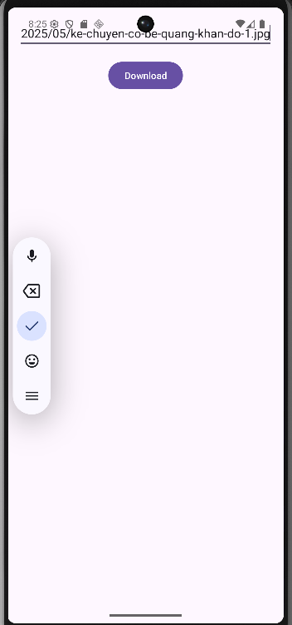
- Nhấn nút Download.
- Nếu đang dùng Android 13+, một hộp thoại xin quyền hiển thị thông báo sẽ hiện ra. Hãy chấp nhận.
- Một thông báo sẽ xuất hiện trên thanh trạng thái.
- Kéo thanh trạng thái xuống để xem chi tiết Notification. Bạn sẽ thấy progress bar đang chạy.
- Thử các nút:
- Nhấn nút Pause: Quá trình tải sẽ tạm dừng. Icon nút sẽ chuyển thành "Play".
- Nhấn nút Resume (lúc này là icon "Play"): Quá trình tải sẽ tiếp tục.
- Nhấn nút Cancel: Service sẽ dừng, tiến trình tải bị hủy, và Notification bị xóa.
- Kiểm tra file đã tải: Sau khi tải xong, bạn có thể dùng Device File Explorer trong Android Studio để vào thư mục data/data/<your.package.name>/files và sẽ thấy file downloaded_file.dat ở đó.
